**Felix Young - BF01 - 2702274513 – Dokumentasi Website Asphatl 9: Rejends**

1. File dan link referensi asset

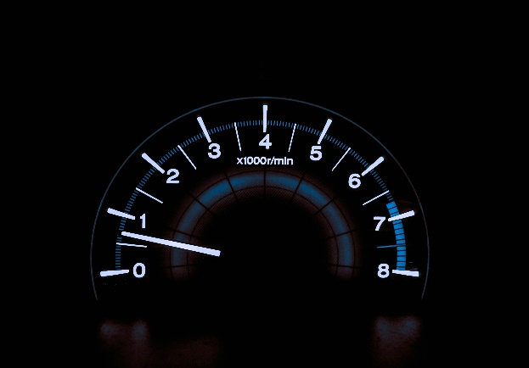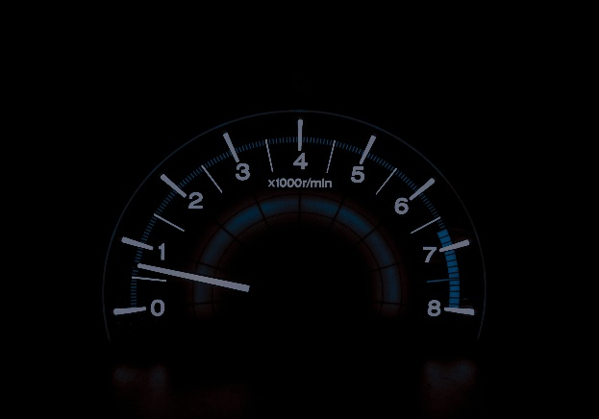

Link : <https://unsplash.com/photos/silhouette-of-car-under-starry-sky-during-nighttime-Lxj4qx09fco>

Link : <https://unsplash.com/photos/white-and-blue-analog-tachometer-gauge-HUJDz6CJEaM>

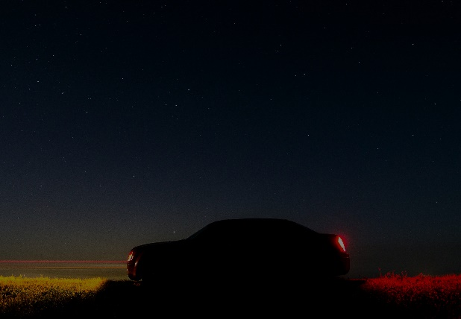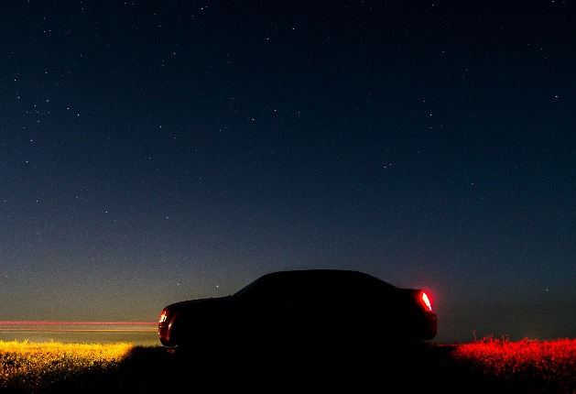

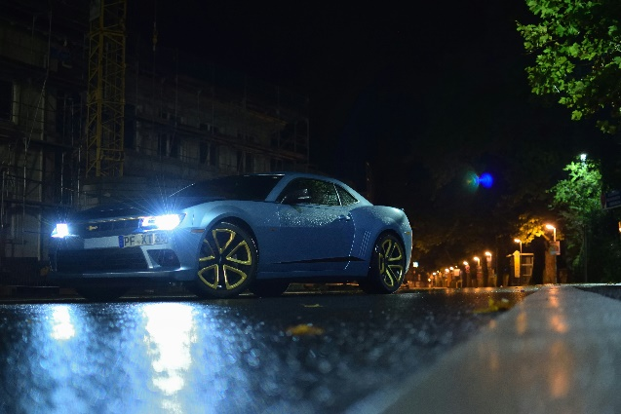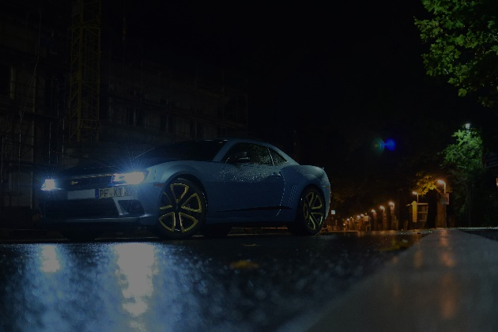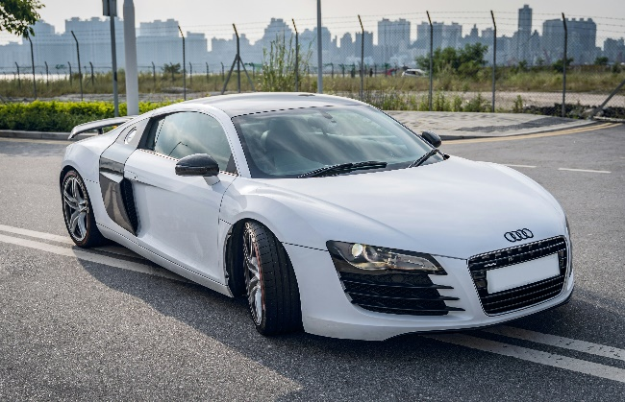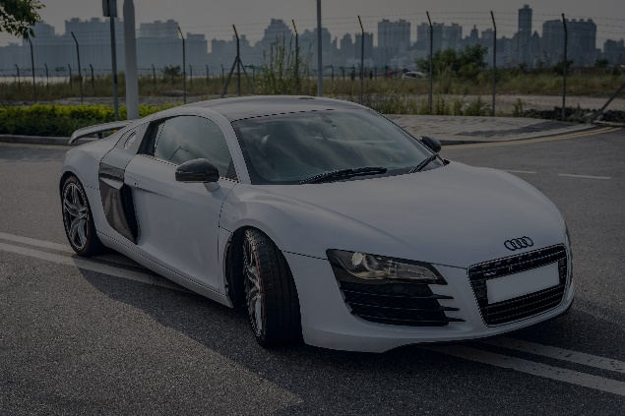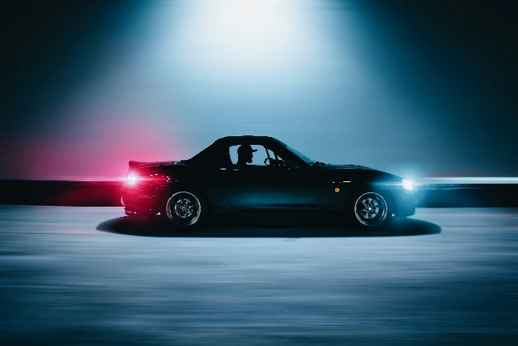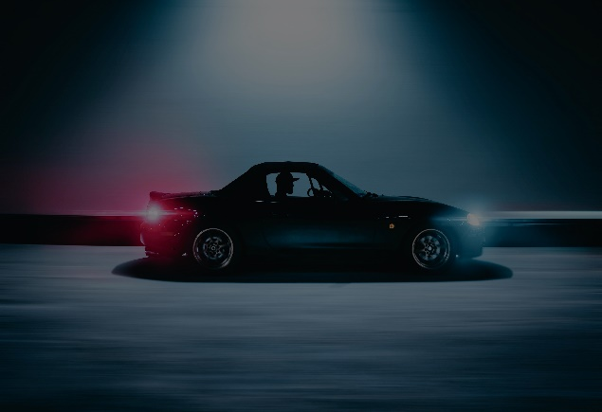

Link : <https://unsplash.com/photos/blue-sports-coupe-on-road-during-nighttime-YpdH7ugbdJo>

Link : <https://unsplash.com/photos/white-audi-r-8-parked-on-parking-lot-during-daytime-PtoAvYUWn7I>

Link : <https://unsplash.com/photos/black-coupe-on-road-8xbPx6Mah5Q>

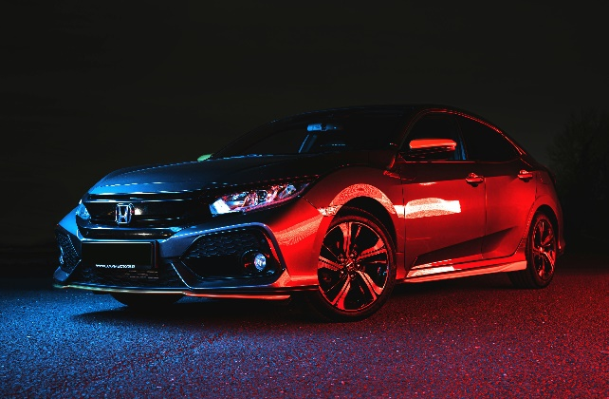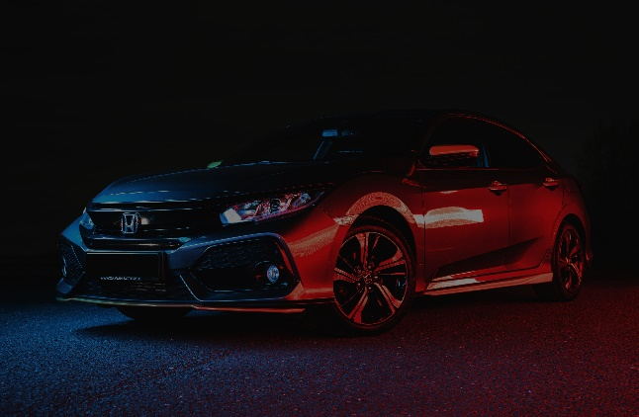

Link : <https://unsplash.com/photos/red-bmw-m-3-coupe-1ZhZpP91olQ>

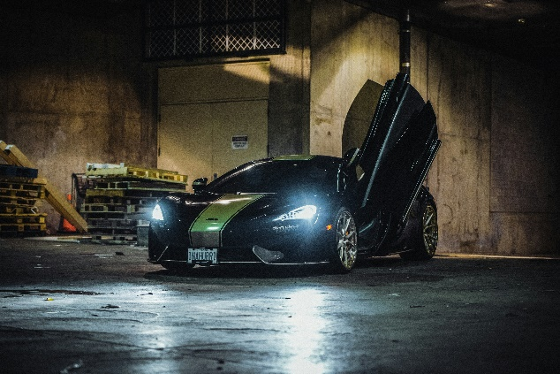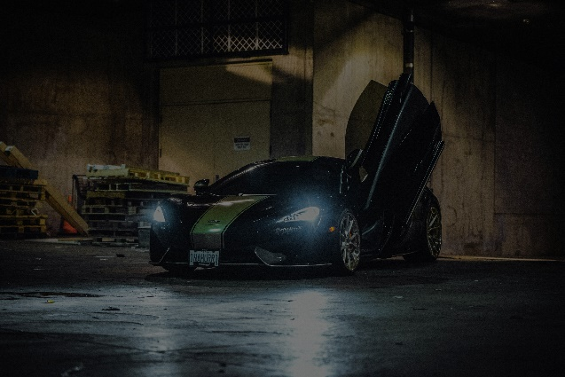

Link : <https://unsplash.com/photos/black-sports-car-with-open-door-parking-near-building-o3ttVJcaFI0>

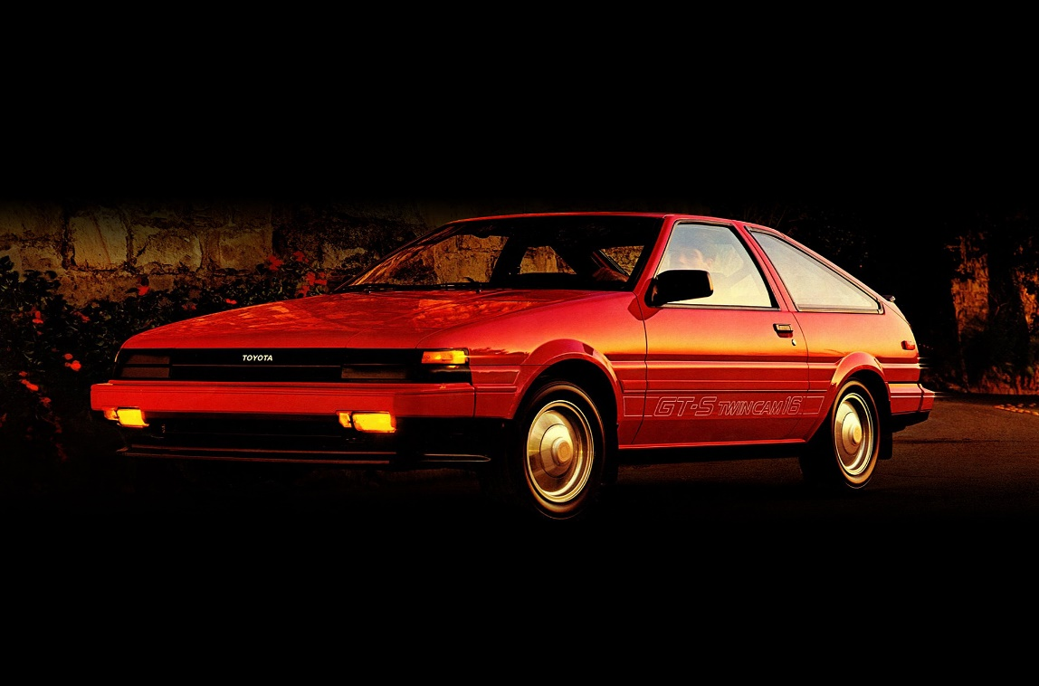

Link : [https://www.wsupercars.com/car-wallpaper download/?title=1983%20Toyota%20Sprinter%20Trueno&res=1920%20x%201440&pic=https://www.wsupercars.com/wallpapers-regular/Toyota/1983-Toyota-Sprinter-Trueno-AE86-003-1440.jpg](https://www.wsupercars.com/car-wallpaper-download/?title=1983%20Toyota%20Sprinter%20Trueno&res=1920%20x%201440&pic=https://www.wsupercars.com/wallpapers-regular/Toyota/1983-Toyota-Sprinter-Trueno-AE86-003-1440.jpg)

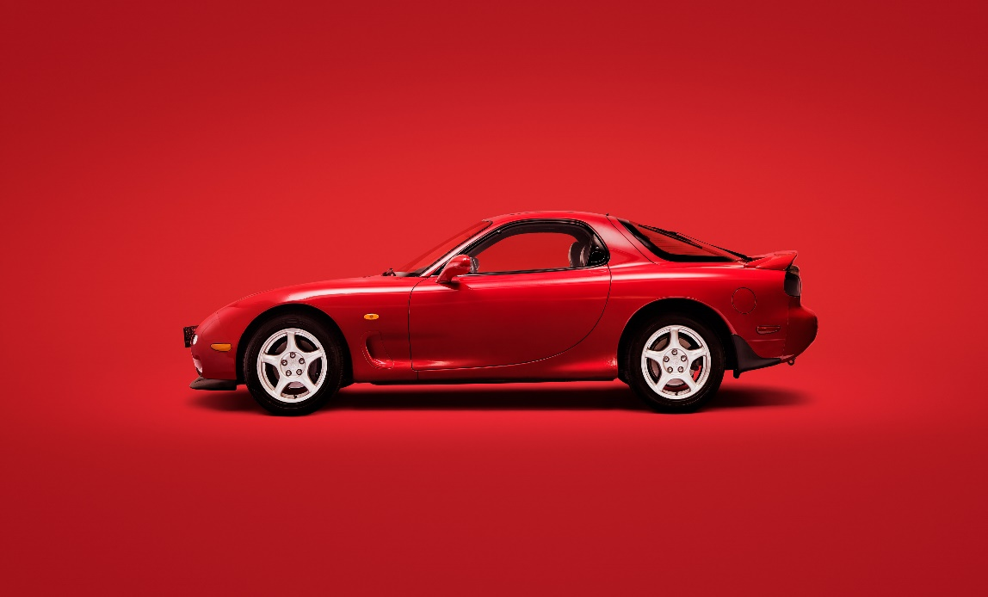

Link : <https://www.wsupercars.com/car-wallpaper-download/?title=1991%20Mazda%20RX-7&res=3840%20x%202160&pic=https://www.wsupercars.com/wallpapers-regular/Mazda/1991-Mazda-RX-7-002-2160.jpg>

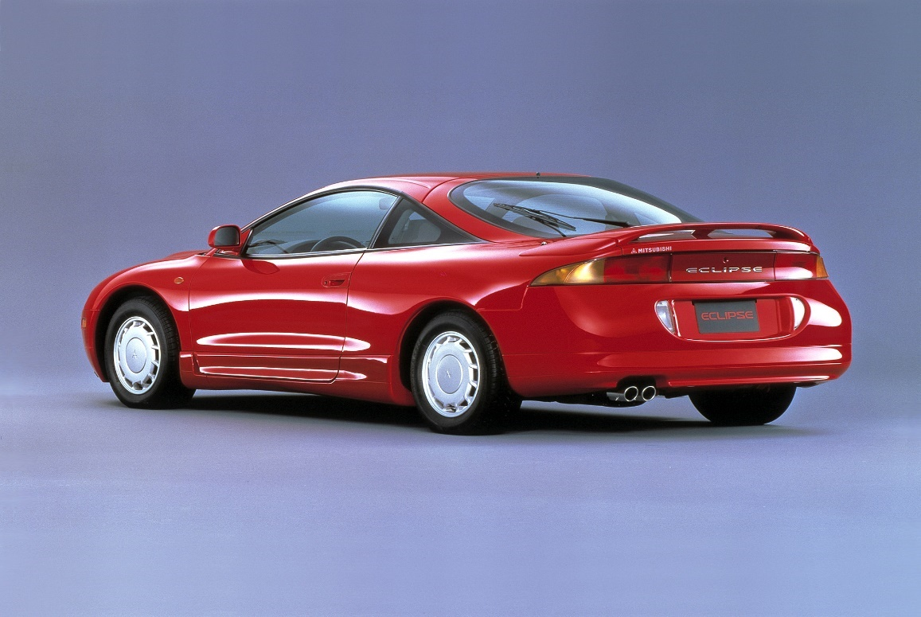

Link : <https://www.wsupercars.com/car-wallpaper-download/?title=1995%20Mitsubishi%20Eclipse&res=1920%20x%201440&pic=https://www.wsupercars.com/wallpapers-regular/Mitsubishi/1995-Mitsubishi-Eclipse-002-1440.jpg>

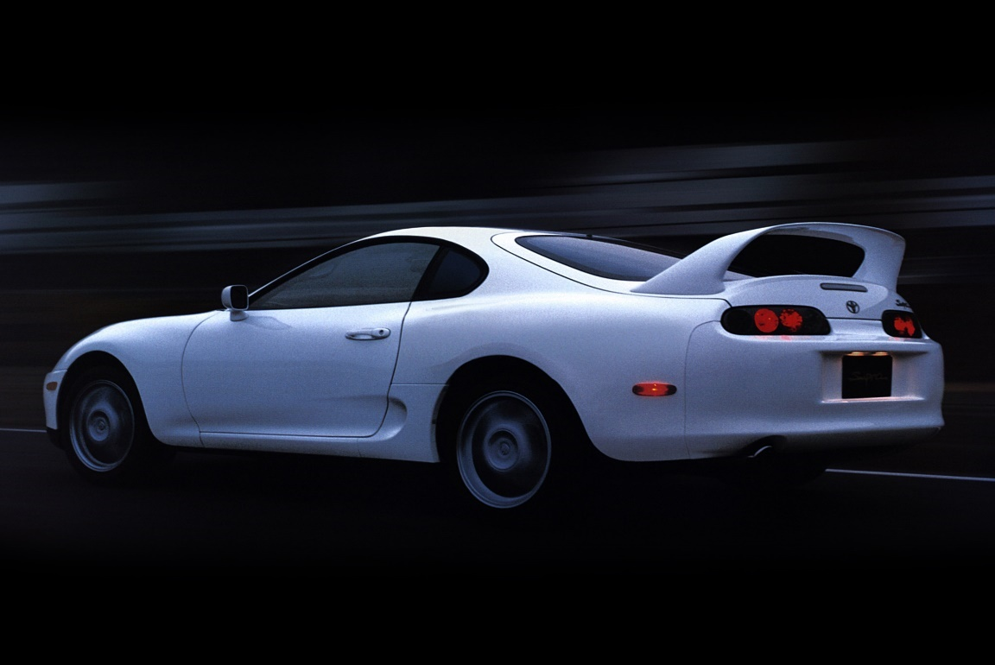

Link : <https://www.wsupercars.com/car-wallpaper-download/?title=1997%20Toyota%20Supra&res=2048%20x%201536&pic=https://www.wsupercars.com/wallpapers-regular/Toyota/1997-Toyota-Supra-006-1536.jpg>

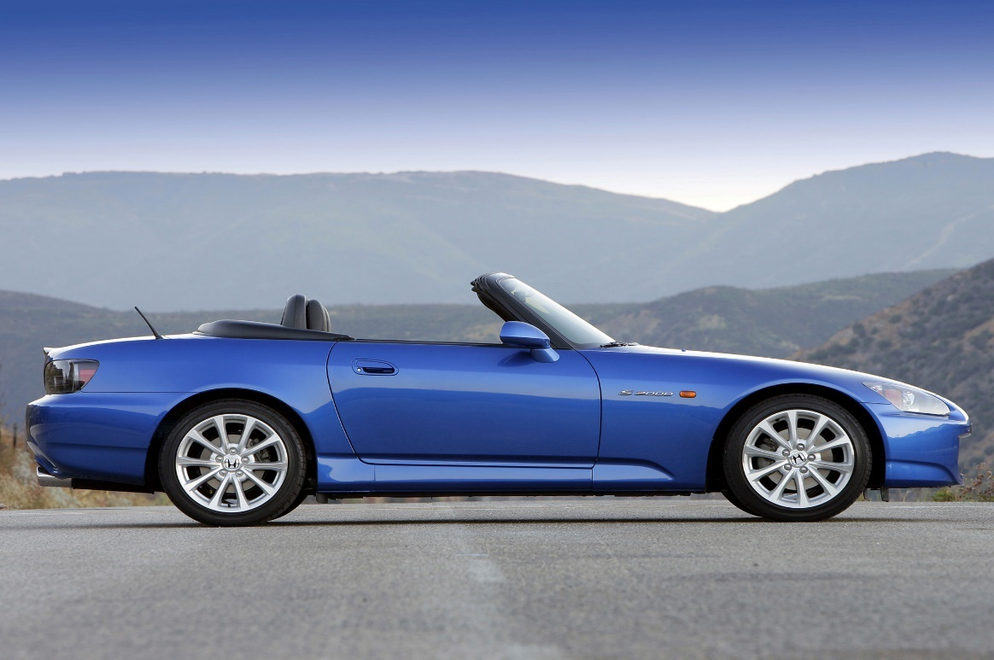

Link : <https://www.wsupercars.com/car-wallpaper-download/?title=2003%20Honda%20S2000&res=1920%20x%201440&pic=https://www.wsupercars.com/wallpapers-regular/Honda/2003-Honda-S2000-008-1440.jpg>

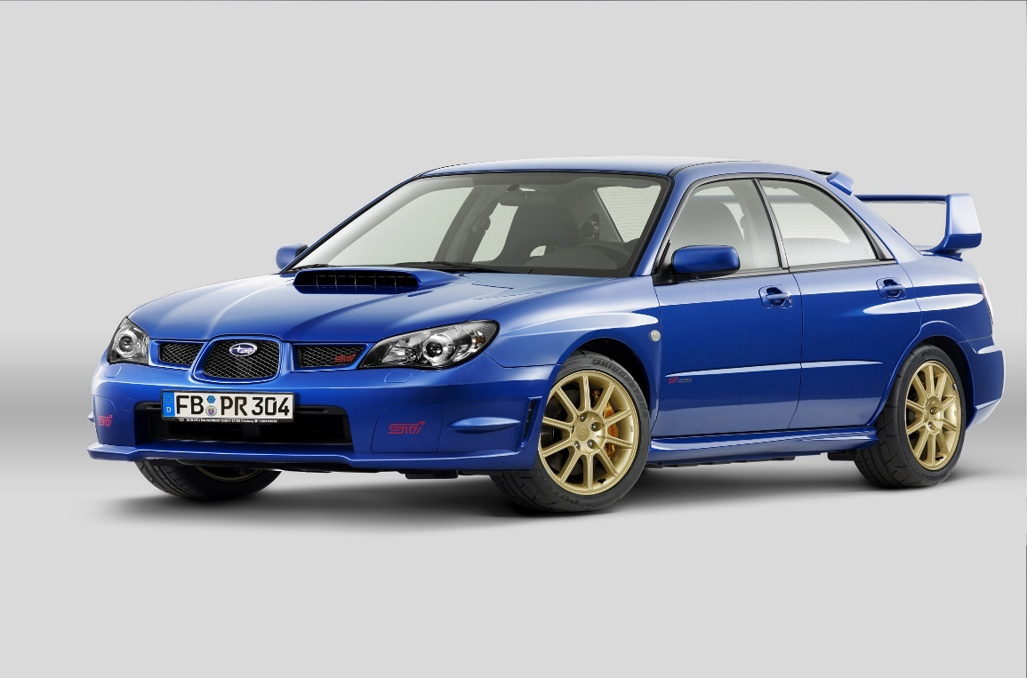

Link : <https://www.wsupercars.com/car-wallpaper-download/?title=2007%20Subaru%20Impreza%20WRX%20STI&res=2048%20x%201536&pic=https://www.wsupercars.com/wallpapers-regular/Subaru/2007-Subaru-Impreza-WRX-STI-011-1536.jpg>

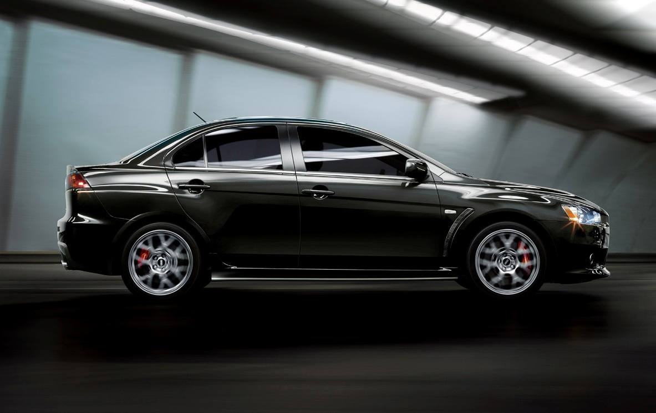

Link : <https://www.wsupercars.com/car-wallpaper-download/?title=2011%20Mitsubishi%20Lancer%20EVO%20X&res=1920%20x%201200&pic=https://www.wsupercars.com/wallpapers-regular/Mitsubishi/2011-Mitsubishi-Lancer-Evolution-X-004-1200.jpg>

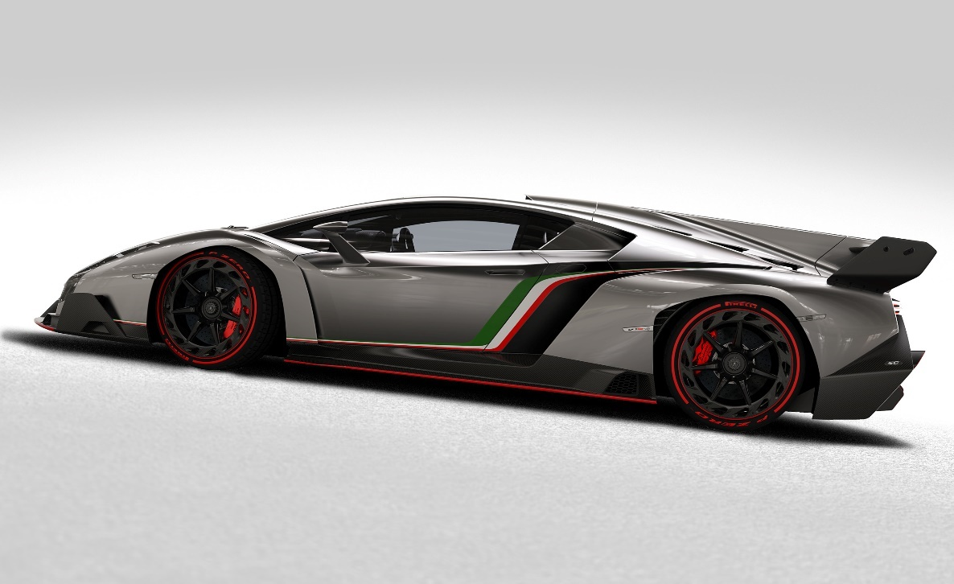

Link : <https://www.wsupercars.com/car-wallpaper-download/?title=2013%20Lamborghini%20Veneno&res=2560%20x%201600&pic=https://www.wsupercars.com/wallpapers-regular/Lamborghini/2013-Lamborghini-Veneno-006-1600.jpg>

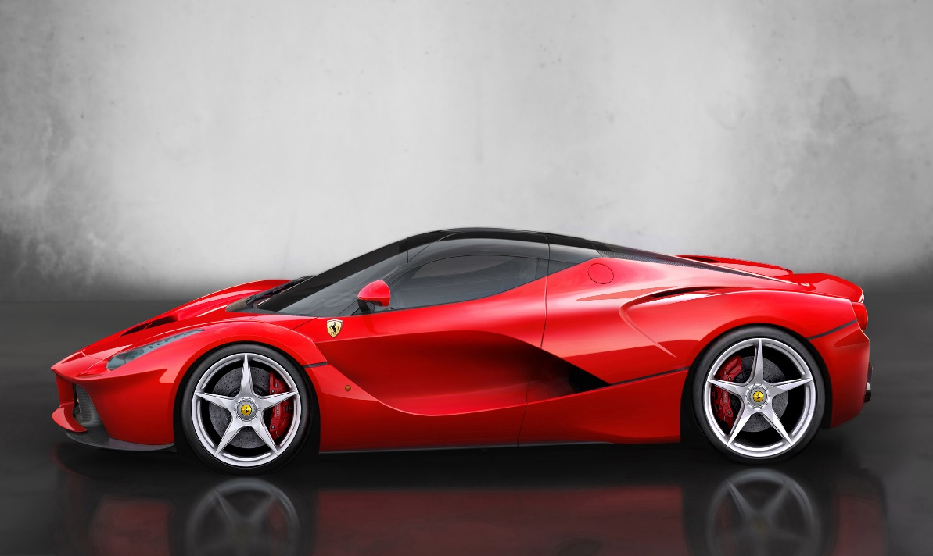

Link : <https://www.wsupercars.com/car-wallpaper-download/?title=2014%20Ferrari%20LaFerrari&res=3840%20x%202160&pic=https://www.wsupercars.com/wallpapers-regular/Ferrari/2014-Ferrari-LaFerrari-002-2160.jpg>

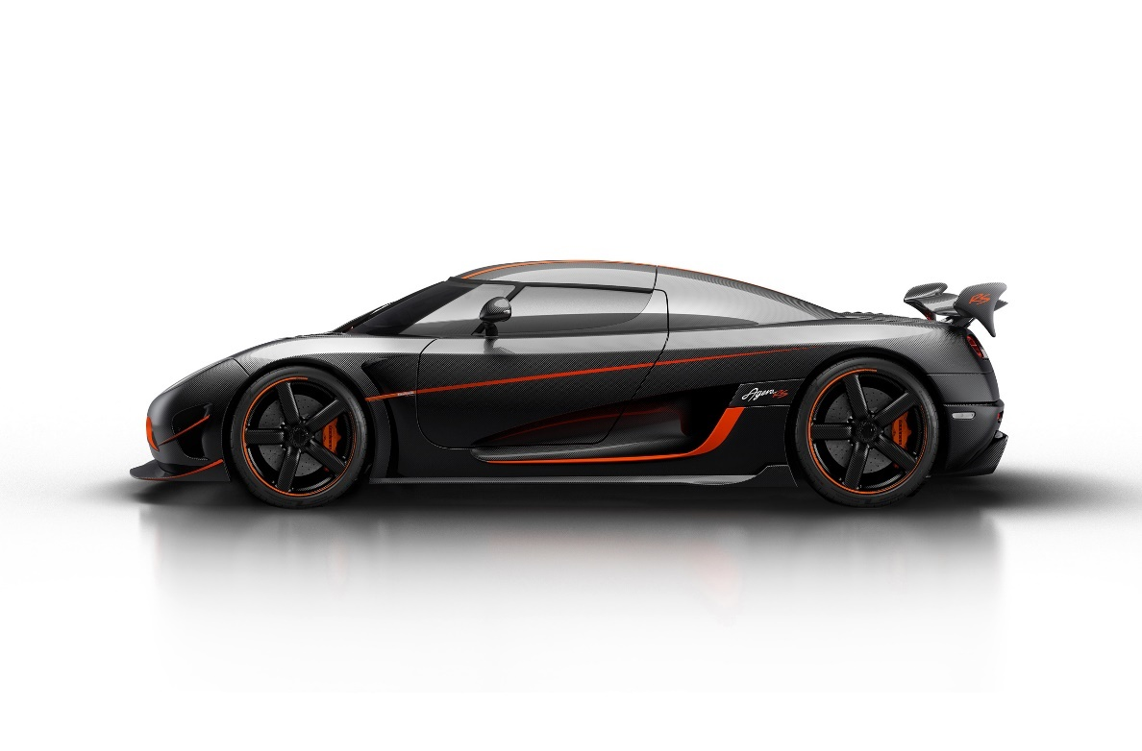

Link : <https://www.wsupercars.com/car-wallpaper-download/?title=2015%20Koenigsegg%20Agera%20RS&res=2560%20x%201600&pic=https://www.wsupercars.com/wallpapers-regular/Koenigsegg/2015-Koenigsegg-Agera-RS-002-1600.jpg>

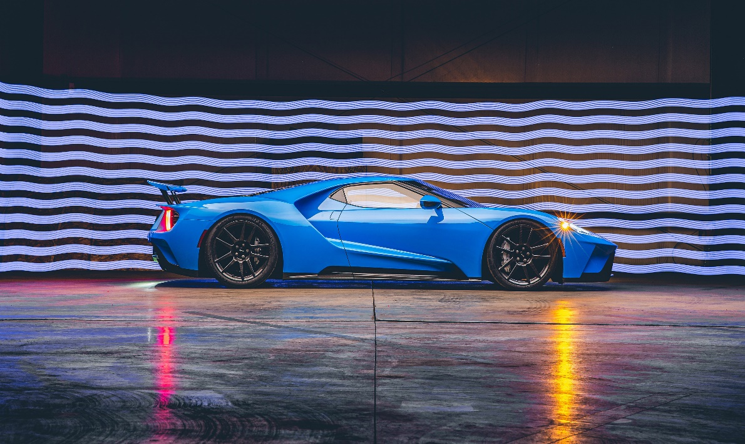

Link : <https://www.wsupercars.com/car-wallpaper-download/?title=2017%20Ford%20GT&res=3840%20x%202160&pic=https://www.wsupercars.com/wallpapers-regular/Ford/2017-Ford-GT-015-2160.jpg>

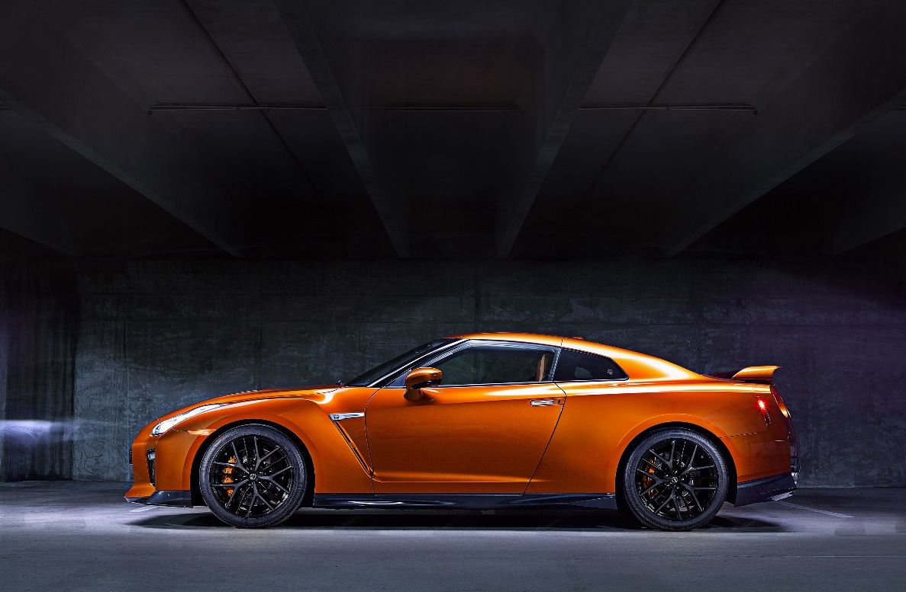

Link : <https://www.wsupercars.com/car-wallpaper-download/?title=2017%20Nissan%20GT-R&res=3000%20x%202000&pic=https://www.wsupercars.com/wallpapers-regular/Nissan/2017-Nissan-GT-R-004-2000.jpg>

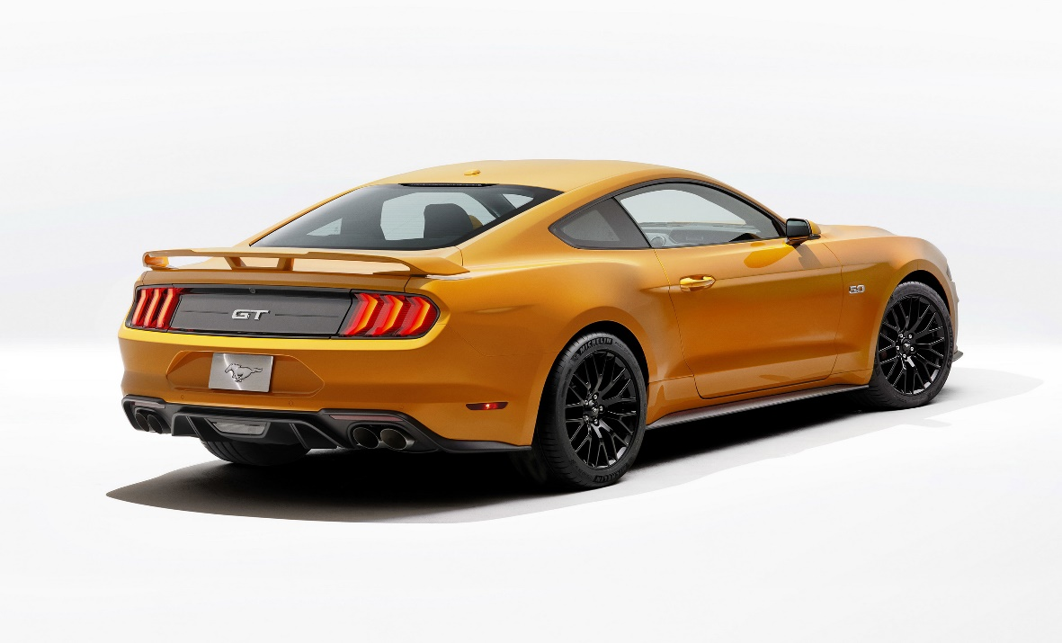

Link : <https://www.wsupercars.com/car-wallpaper-download/?title=2018%20Ford%20Mustang%20GT&res=3000%20x%202000&pic=https://www.wsupercars.com/wallpapers-regular/Ford/2018-Ford-Mustang-GT-008-2000.jpg>

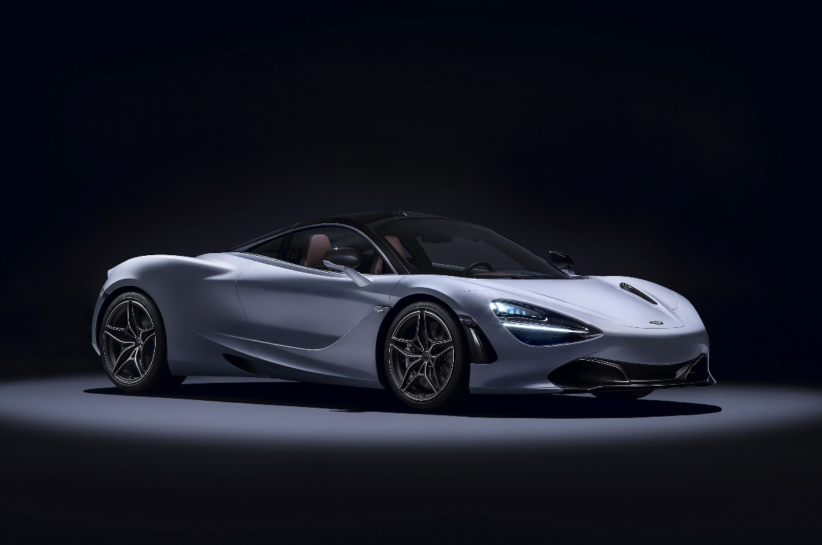

Link : <https://www.wsupercars.com/car-wallpaper-download/?title=2018%20McLaren%20720S&res=3000%20x%202000&pic=https://www.wsupercars.com/wallpapers-regular/McLaren/2018-McLaren-720S-010-2000.jpg>

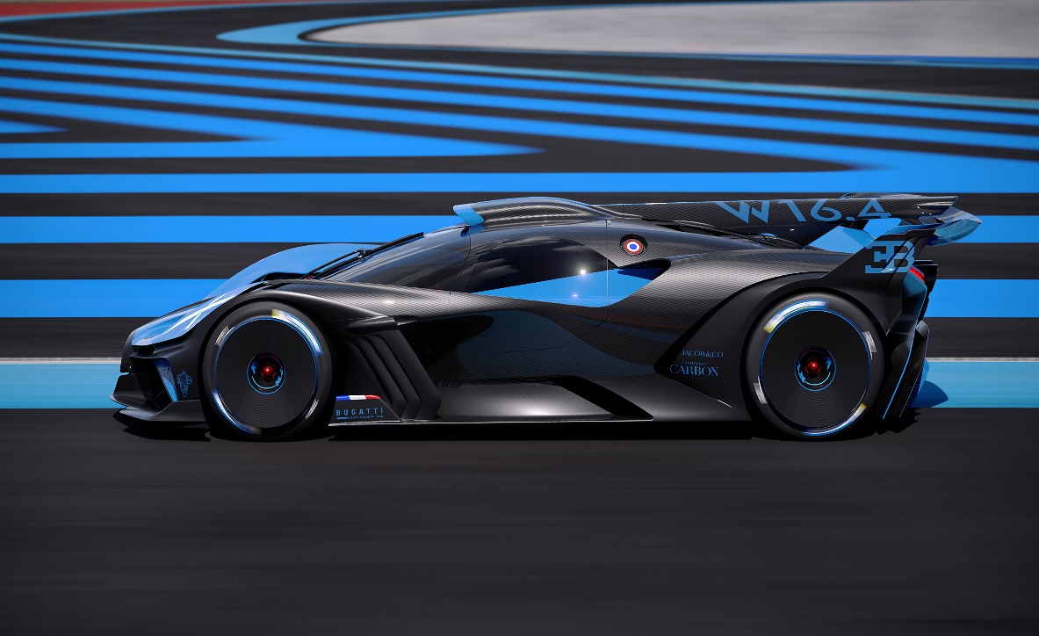

Link : <https://www.wsupercars.com/car-wallpaper-download/?title=2020%20Bugatti%20Bolide%20Concept&res=3840%20x%202160&pic=https://www.wsupercars.com/wallpapers-regular/Bugatti/2020-Bugatti-Bolide-Concept-010-2160.jpg>

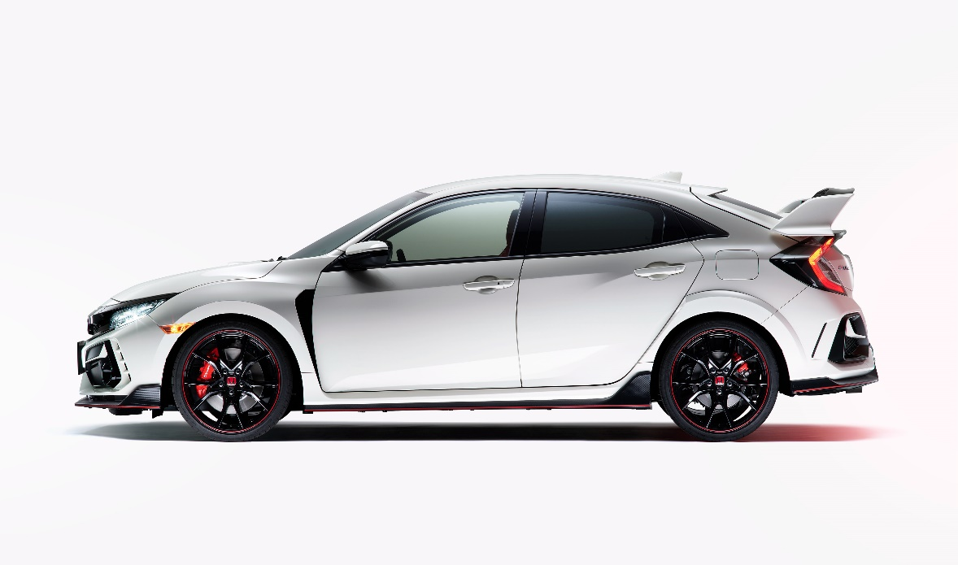

Link : <https://www.wsupercars.com/car-wallpaper-download/?title=2020%20Honda%20Civic%20Type%20R&res=3840%20x%202160&pic=https://www.wsupercars.com/wallpapers-regular/Honda/2020-Honda-Civic-Type-R-006-2160.jpg>

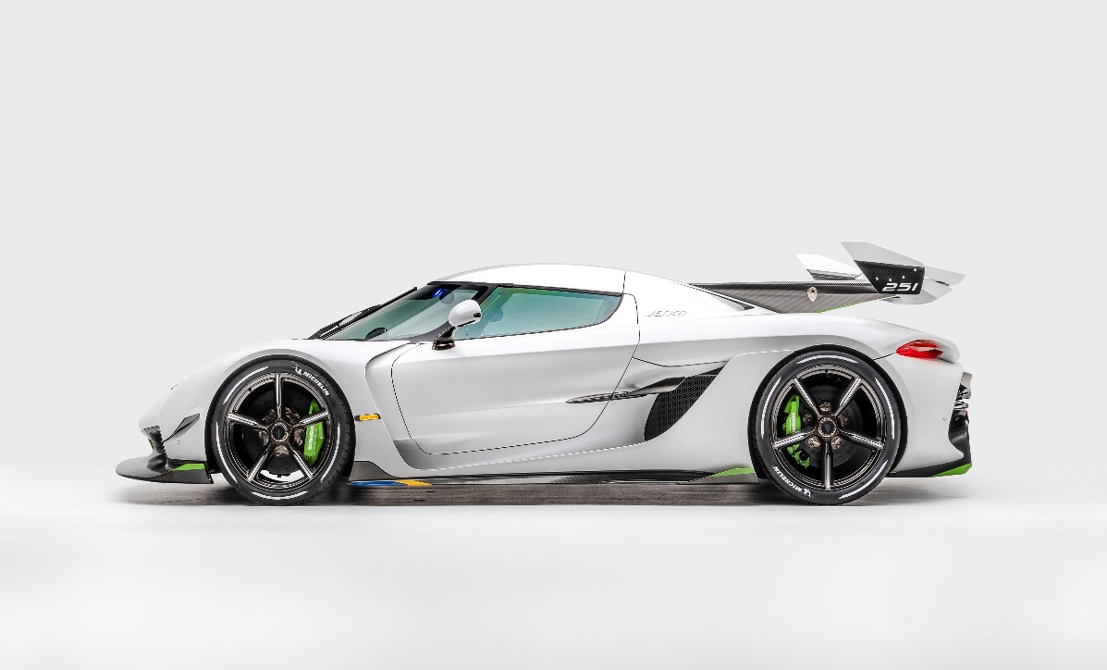

Link : <https://www.wsupercars.com/car-wallpaper-download/?title=2020%20Koenigsegg%20Jesko&res=3480%20x%202160&pic=https://www.wsupercars.com/wallpapers-regular/Koenigsegg/2020-Koenigsegg-Jesko-003-2160.jpg>

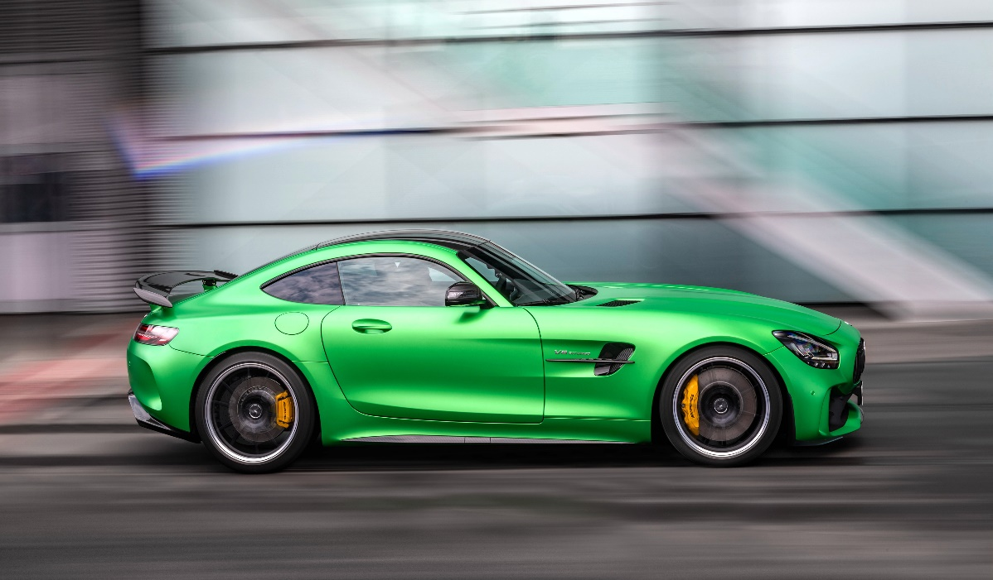

Link : <https://www.wsupercars.com/car-wallpaper-download/?title=2020%20Mercedes-AMG%20GT%20R&res=3840%20x%202160&pic=https://www.wsupercars.com/wallpapers-regular/Mercedes-Benz/2020-Mercedes-AMG-GT-R-005-2160.jpg>

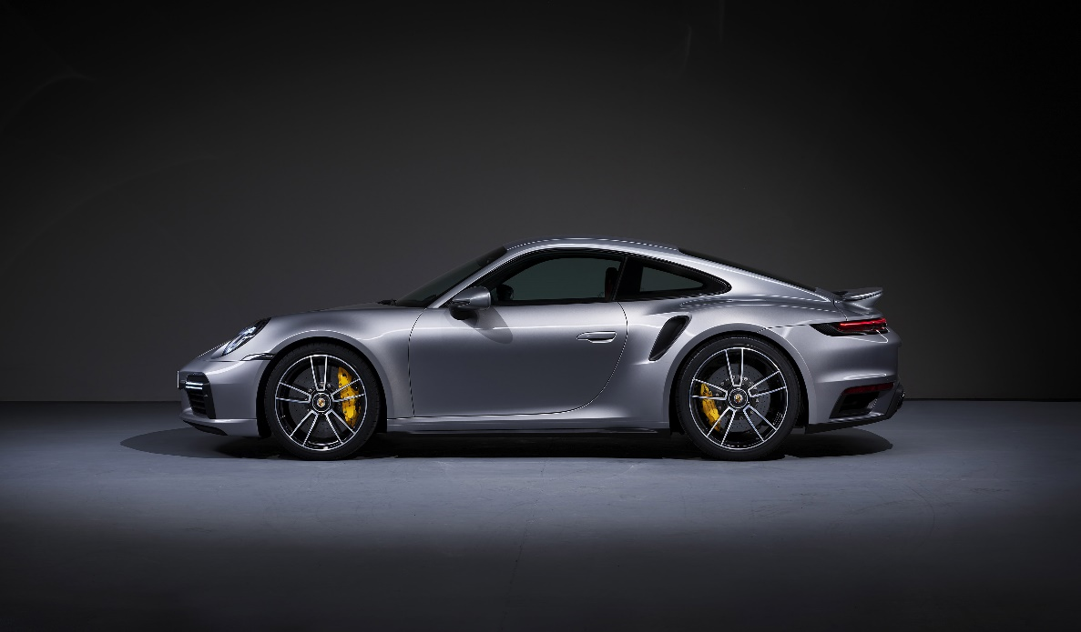

Link : <https://www.wsupercars.com/car-wallpaper-download/?title=2020%20Porsche%20911%20Turbo%20S&res=3840%20x%202160&pic=https://www.wsupercars.com/wallpapers-regular/Porsche/2020-Porsche-911-Turbo-S-002-2160.jpg>

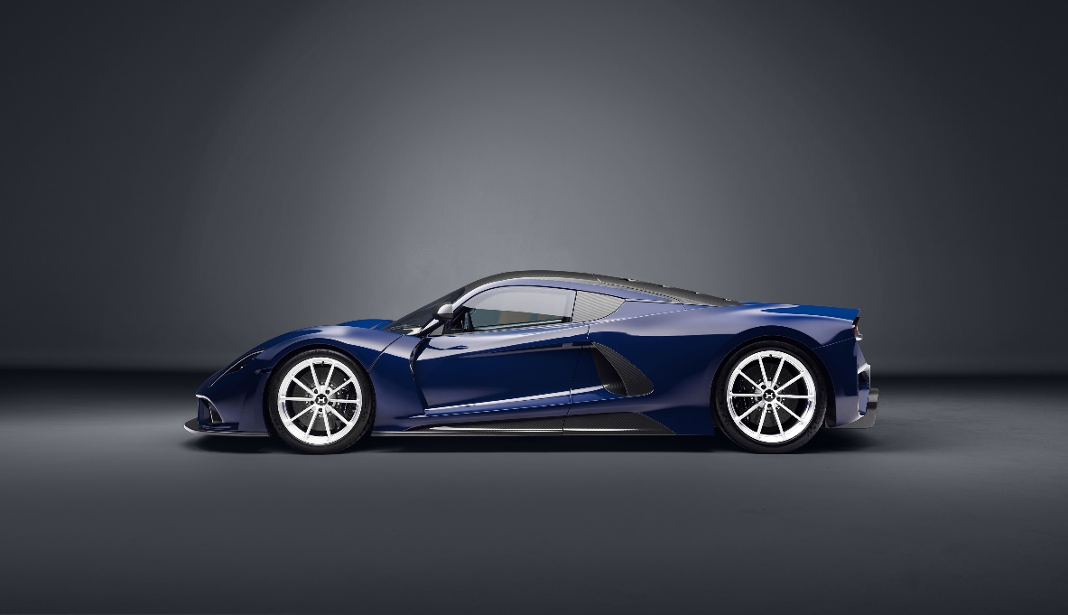

Link : <https://www.wsupercars.com/car-wallpaper-download/?title=2021%20Hennessey%20Venom%20F5&res=3840%20x%202160&pic=https://www.wsupercars.com/wallpapers-regular/Hennessey/2021-Hennessey-Venom-F5-002-2160.jpg>

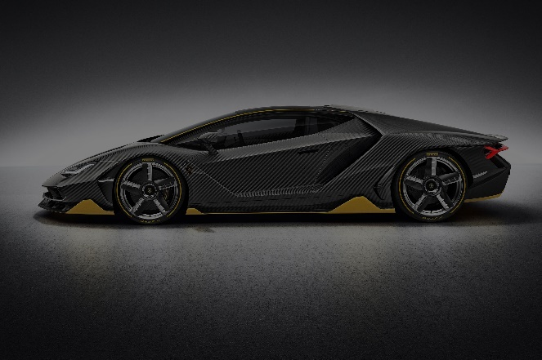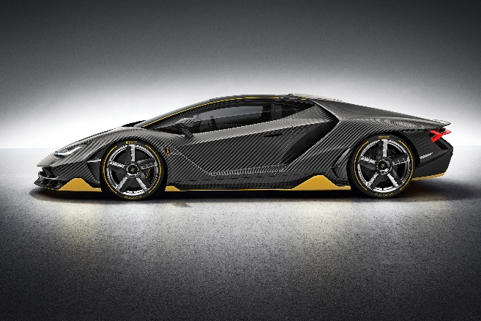

Link : <https://www.wsupercars.com/car-wallpaper-download/?title=2017%20Lamborghini%20Centenario&res=3000%20x%202000&pic=https://www.wsupercars.com/wallpapers-regular/Lamborghini/2017-Lamborghini-Centenario-003-2000.jpg>

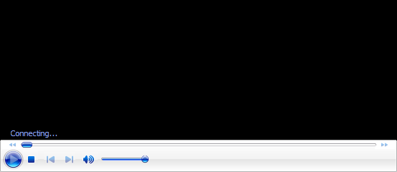

Link : <https://www.pexels.com/video/luxury-sports-cars-passing-on-the-street-5309381/>



Link : Buatan saya sendiri, dengan cara buat h1 terlebih dahulu di websitenya sebagai logo lalu di screenshot lalu di crop. Untuk font h1 nya, saya ambil dari CDNFonts, linknya adalah <https://www.cdnfonts.com/ninjabot.font>. Kemudian, saya ganti logo tersebut dari h1 menjadi gambar-gambar ini.

Catatan tambahan : Ada beberapa gambar mobil yang memiliki 2 jenis, yaitu yang original dan yang telah diturunkan tingkat exposurenya. Penurunan tingkat exposure ini memiliki tujuan untuk memperjelas tampilan website.

2. Setiap halaman web dan penjelasan singkatnya

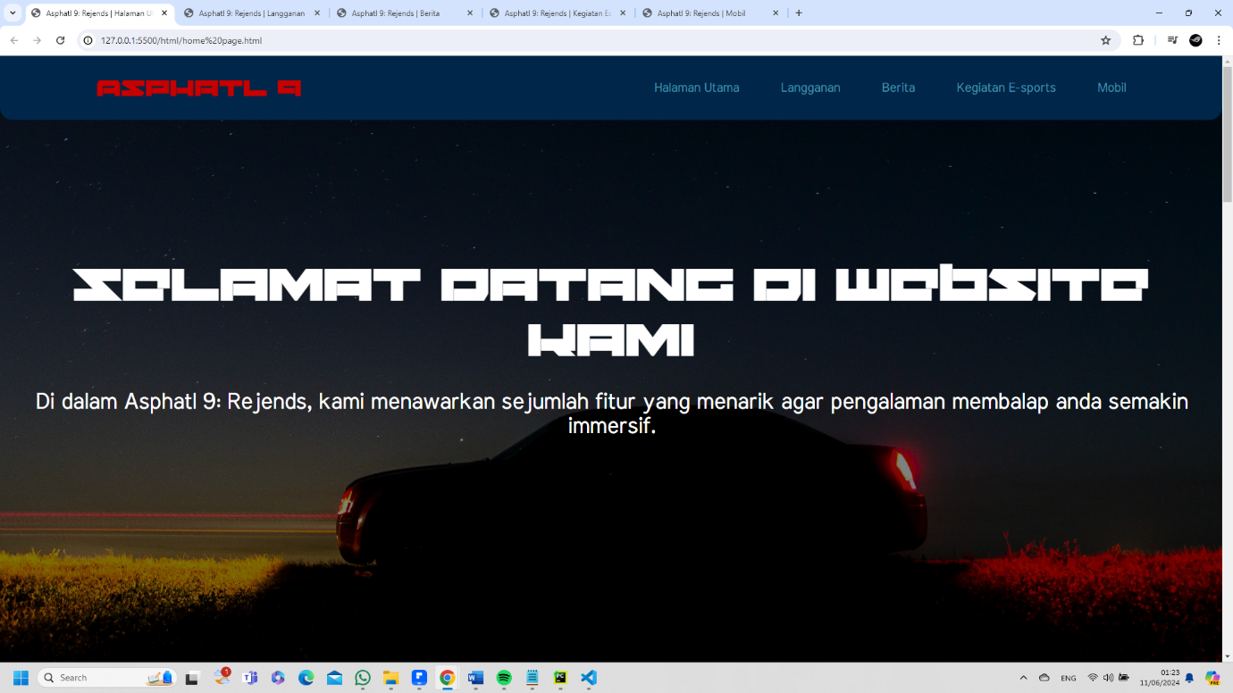

Home Page/Halaman Utama menampilkan ucapan selamat datang dan fitur-fitur yang menarik dalam game Asphatl 9: Rejends.

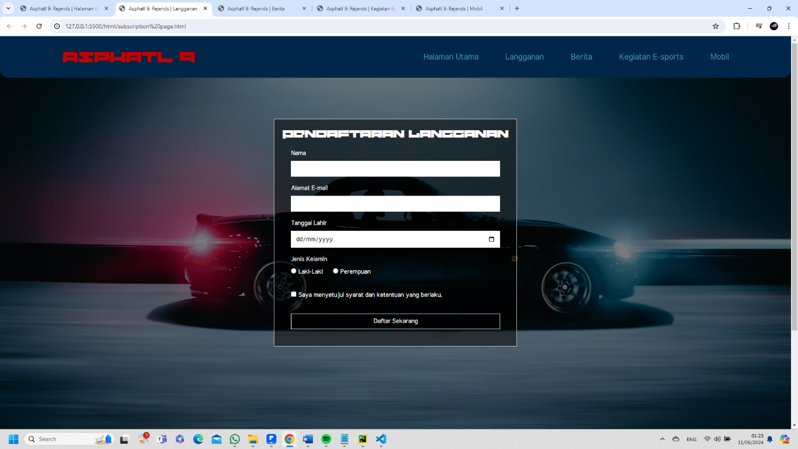

Subscription Page/Halaman Langganan mempersilahkan user untuk mengisi data2 yaitu nama, alamat e-mail, tanggal lahir, jenis kelamin, dan persetujuan syarat dan ketentuan yang berlaku dan terdapat validasi input.

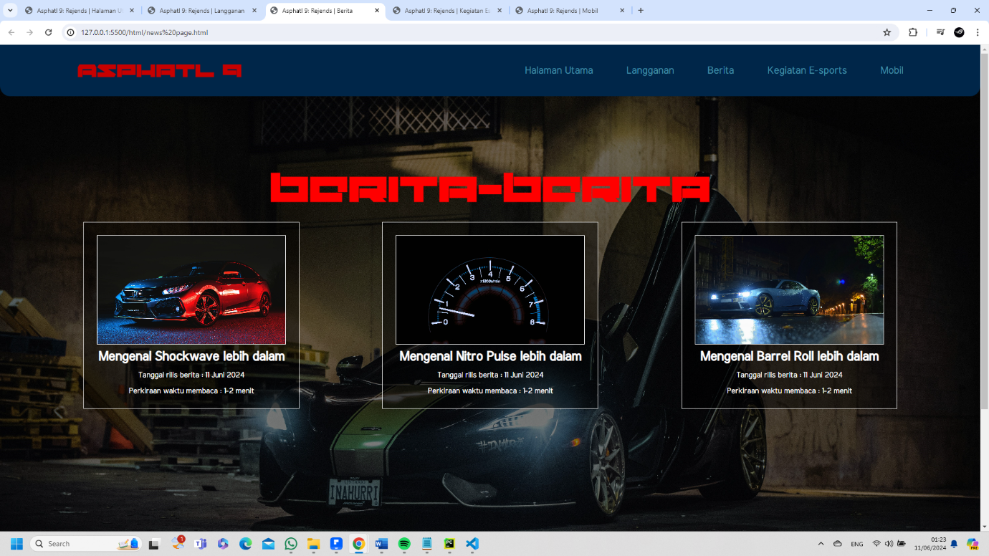

News Page/Halaman Berita menampilkan daftar-daftar berita yang ada beserta tanggal rilis dan perkiraan waktu membacanya.

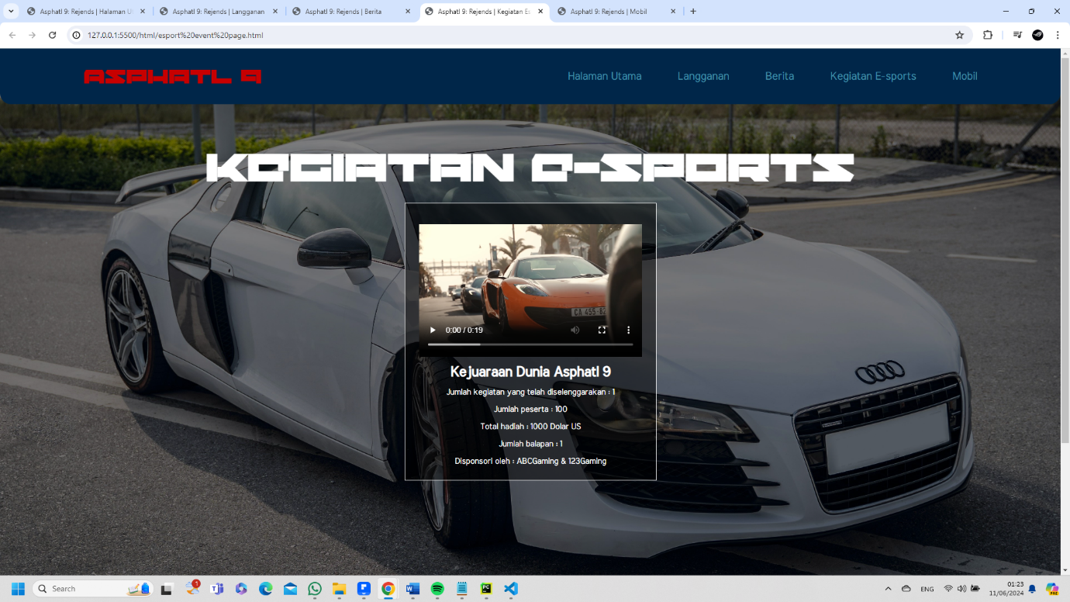

Esport Event Page/Halaman Kegiatan E-sports menampilkan kegiatan-kegiatan e-sports yang ada beserta jumlah kegiatan yang telah diselenggarakan, jumlah peserta, total hadiah, jumlah balapan, dan para sponsornya.

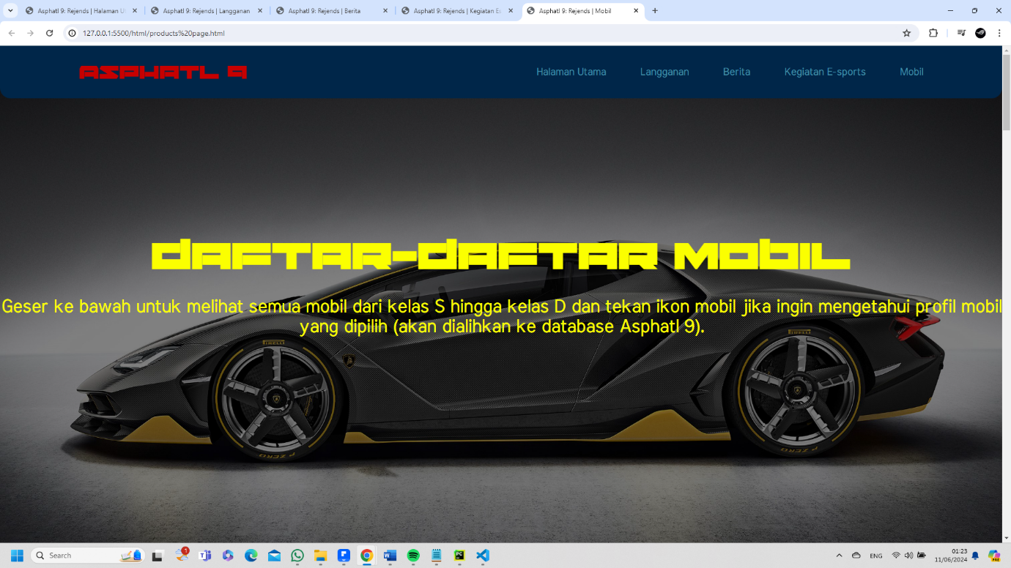

Products Page/Halaman Mobil menampilkan 4 mobil dari setiap kelasnya, yaitu kelas S, kelas A, kelas B, kelas C, dan kelas D.